Case 4-Eur-Italy-Roman-Bronze bust-Female-200 CE

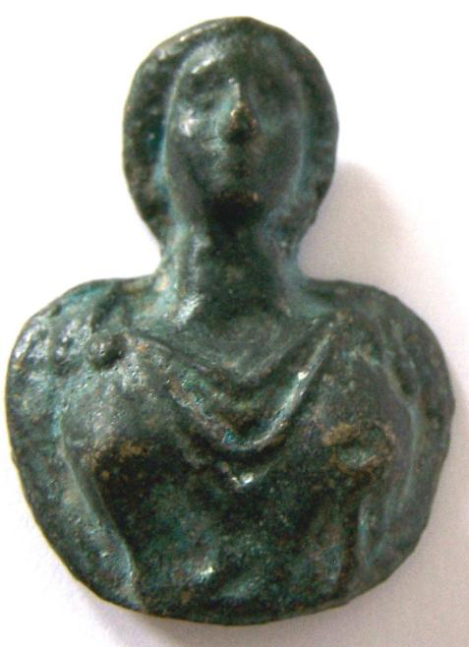
Italy-Roman-Bronze bust-Female
Case no.: 4
Accession Number:
Formal Label: Roman-Bronze bust-Female
Display Description: This individual wears a toga and a flower-shaped fibula which was in vogue during the 2nd -3rd centuries CE.
Roman bronze female busts like this one may have accompanied legionnaires in their various exploits to remind them of their loved ones at home.
LC Classification:
Date or Time Horizon: 200 CE
Geographical Area: Rome
Map:
GPS coordinates:
Cultural Affiliation: Roman
Medium: bronze
Dimensions: H 4 cm, W 3 cm
Weight:
Condition:
Provenance:
Discussion:
References:

Payment details


Shipping details
Ralph J Coffman Jr
149 Atlantic Ave
Swampscott MA 01907-2427
United States

Order details
Item title | Available actions | Shipping & handling (estimated delivery*) | Price

Seller: | Member id antiquewd ( Feedback Score Of 1433) | Contact seller

Order # 123464626018
Paid on Oct-28-12 via PayPal
Contact seller

Roman style bronze face- opens in a new window or tab
Item Id:360501217436 - Price: US $76.00
Quantity:1
Having a problem with this purchase? We can help
Leave feedback

Shipped with item above
Package 1 of 1
Shipment details: 9410809699937262021869
US $76.00

